NAME : JANUTH ADITHA ABEYSINGHE
STUDENT ID : S225644509
UNIT : SIT725-APPLIED SOFTWARE ENGINEERING
TASK 3.2P

REPO LINK : https://github.com/Janutimate/SIT725_s225644509.git

SCREENSHOTS :


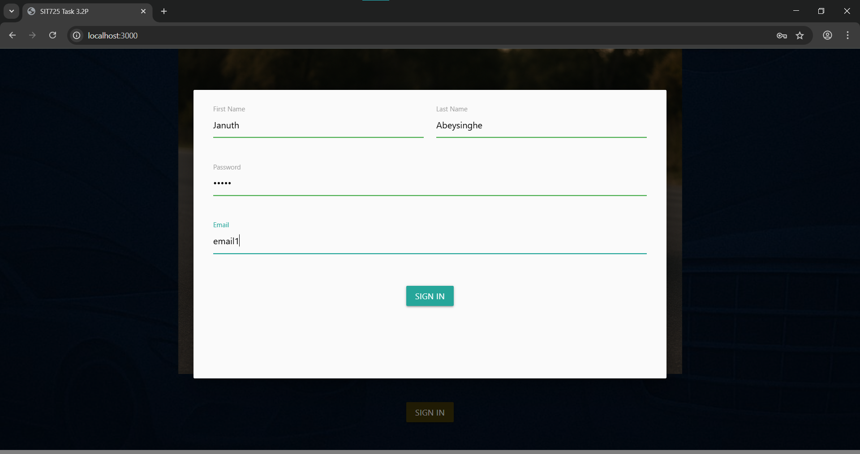
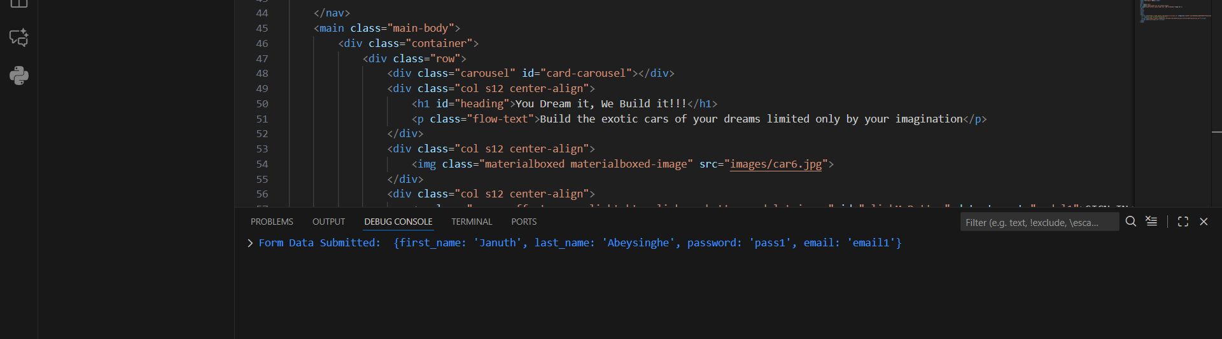

WORKING CODE :

